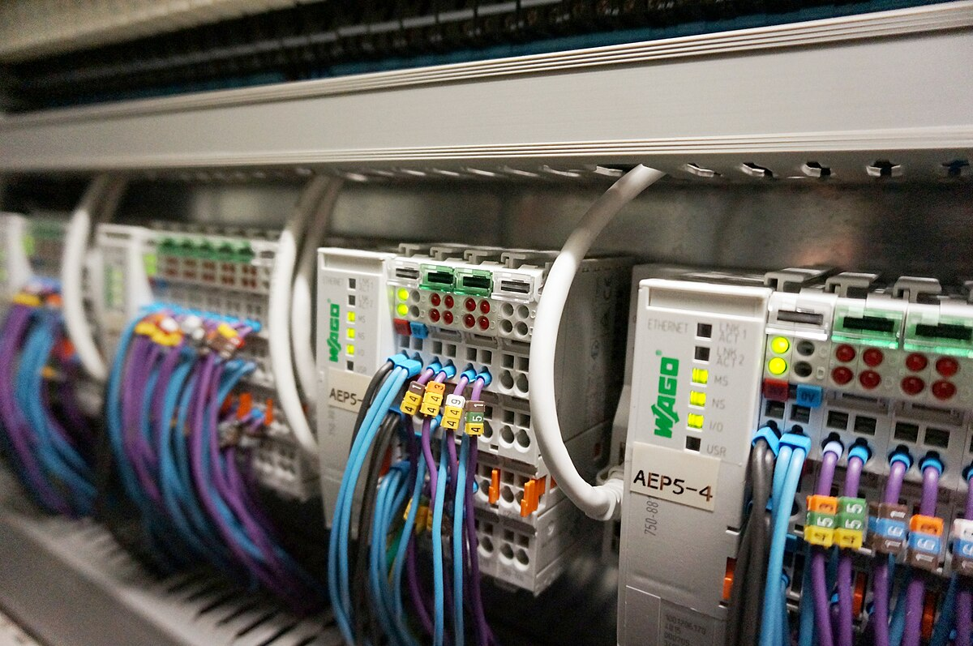Presented To: Dr. Mohamed Omar

MCT313   
Automation

Major Task Phase one

Tank level PID Control

Eng. Nourhan Emad

Eng. Mina El Kess

Presented By: Team 7

Omar Mohamed Mohamed 21P0274

Omar Waleed 21P0083

Yahia Mohamed 21P0041

Table of Contents

1.0 ABSTRACT 3

2.0 INTRODUCTION 3

3.0 PROJECT OVERVIEW 3

3.1 System Description 3

3.2 Project Objectives 3

4.0 SOFTWARE SETUP 3

4.1 Tia Portal 3

4.2 Factory IO 3

5.0 SYSTEM CONFIGURATION 3

5.1 PLC Networks 3

5.2 PLC Tags 3

6.0 CONTROL 3

6.1 Inputs and Outputs 3

6.2 PID Control (compact PID) 3

7.0 HMI (Human – Machine Interface) 3

7.1 HMI Features 3

7.2 Alarm System 3

8.0 SIMULATION AND RESULTS 3

9.0 CONCLUSION 4

**No table of figures entries found.**

# 1.0 ABSTRACT

This project presents a PLC-based water tank level control system implemented using Siemens TIA Portal and simulated through Factory I/O. The system maintains the liquid level in a tank using the Compact PID control block available in TIA Portal, ensuring smooth and precise control. The PID parameters were auto tuned for optimal response. Additionally, a Human-Machine Interface (HMI) was designed to allow operators to monitor and control the system remotely. The HMI enables setpoint adjustment, manual override, and real-time level visualization. To enhance safety and awareness, an alarm system was integrated into the HMI to notify users of various tank conditions, such as high, low, and critical levels. This project demonstrates the effectiveness of PLCs in industrial process control and highlights the value of integrating PID, HMI, and alarm handling into a comprehensive control solution.

# 2.0 INTRODUCTION

Industrial process control plays a vital role in modern manufacturing and production systems, where automation ensures efficiency, accuracy, and safety. One common process in many industries is liquid level control, typically required in sectors such as chemical processing, water treatment, and food production. This project focuses on designing and simulating a tank level control system using a Siemens Programmable Logic Controller (PLC) with TIA Portal and Factory I/O.

The control strategy is implemented using the Compact PID block available in TIA Portal, providing automatic regulation of the water level within the tank. To enhance usability and operator interaction, a dedicated Human-Machine Interface (HMI) was developed. This interface allows users to monitor the system status, change setpoints, and manually control operations when necessary. Moreover, a multi-level alarm system was included in the HMI to indicate abnormal conditions such as overflow or underfill.

This project not only demonstrates the practical use of PID control in a simulated industrial environment but also emphasizes the importance of user interface and alarm management in real-time process control.

# 3.0 PROJECT OVERVIEW

## 3.1 System Description

The project involves the design and simulation of a water tank level control system using Siemens TIA Portal and Factory I/O. The system simulates an industrial environment where the water level within a storage tank must be continuously maintained at a specific setpoint. The tank receives water via an inlet controlled by a valve, and the level is monitored using an analog level sensor. Based on the feedback from the sensor, the Compact PID control block adjusts the valve position to regulate the inflow, ensuring the level remains within acceptable limits.

In addition to the automated PID-based control, the project includes a Human-Machine Interface (HMI) that provides full monitoring and operational capabilities. The HMI displays the current water level, allows setpoint modification, and offers manual control features for system override. The simulation was built in Factory I/O, where all sensors, actuators, and control components are visually represented, providing a realistic virtual environment for testing and validation.

## 3.2 Project Objectives

The primary objectives of this project are as follows:

* To implement closed-loop level control using the Compact PID block in Siemens TIA Portal.
* To auto-tune the PID parameters for optimized and stable system performance.
* To integrate a fully functional HMI that supports:
  + Real-time level visualization
  + Setpoint adjustment
  + Manual/automatic mode switching
  + Alarm notifications for abnormal tank conditions
* To simulate and validate the complete control system using Factory I/O.
* To demonstrate the practical application of PLCs, PID control, and HMIs in industrial automation.

# 4.0 SOFTWARE SETUP

## 4.1 Tia Portal (Totally integrated Automation Portal)

Tia portal is software used for PLC programming on Siemens’ PLC devices accompanied with other software such as PLCSIM to connect with other software like factory IO and WINCC for viewing HMI Layout.

The PLC logic was developed using LAD which is widely used in Industrial Automation.

The simulated **PLC model** used in the project was the Siemens S7-1500 series specifically the **1511-1 PN**. This virtual controller executed automation logic in real-time through **PLC Sim**, managing the behavior of all connected elements in the simulation. Analog signals from the level sensor and control commands to the valve were mapped to the PLC’s I/O structure, simulating a real-world closed-loop control system.

A custom HMI panel, created using WinCC within the TIA Portal, provided the interface between the operator and the control system. The HMI displayed live tank level data, allowed users to modify the level setpoint, and included manual control options for the valve. Furthermore, an alarm management system was integrated to notify the operator of abnormal conditions such as high, low, or critically low tank levels.

## 4.2 Factory IO

Factory I/O was employed to simulate the physical process of the water tank system. The software allows for realistic 3D representation of industrial environments, including tanks, sensors, valves, and piping. Within this simulation, the tank's inlet valve and level sensor were modeled, enabling real-time interaction with the control logic developed in TIA Portal. This integration allows for thorough testing and validation of control algorithms before deploying them to physical hardware.

For this project, we used a preset scene for Tank level control.

# 5.0 SYSTEM CONFIGURATION

## 5.1 PLC Networks

## 5.2 PLC Tags

# 6.0 CONTROL

The core objective of the control strategy is to maintain the water level in the tank at a desired setpoint despite process disturbances, such as inflow variation or demand changes. This is achieved through a closed-loop control system implemented using the Compact PID block available in Siemens TIA Portal. The PID controller continuously monitors the actual tank level using analog feedback from the level sensor and compares it to the user-defined setpoint.

When a deviation between the setpoint and the actual level is detected, the PID controller computes a control output to adjust the inlet valve opening accordingly. This output signal modulates the flow rate of water into the tank, reducing the error over time. The Compact PID block provides internal processing of the Proportional, Integral, and Derivative components, allowing for smooth and stable regulation of the process variable.

## 6.1 Inputs and Outputs

## 6.2 PID Control (compact PID)

# 7.0 HMI (Human – Machine Interface)

## 7.1 HMI Features

## 7.2 Alarm System

# 8.0 SIMULATION AND RESULTS

# 9.0 CONCLUSION

This project successfully demonstrated the design, implementation, and simulation of a water tank level control system using Siemens TIA Portal and Factory I/O. By integrating the Compact PID controller, precise and automated regulation of the tank level was achieved, with minimal overshoot and stable performance. The use of auto-tuning simplified the tuning process and ensured optimal controller response without the need for manual parameter adjustment.

The addition of a custom HMI panel greatly enhanced system usability, offering real-time monitoring, setpoint adjustment, manual override options, and alarm notifications. This user interface allowed for intuitive interaction with the control system and ensured that operators could quickly respond to abnormal conditions.

Overall, the project highlights the effectiveness of PLCs in process automation and illustrates how simulation tools like Factory I/O can be used to validate control strategies in a realistic industrial environment. The integration of PID control, HMI design, and alarm management provides a comprehensive solution that mirrors real-world industrial applications, making this project a valuable learning experience in both automation theory and practical implementation.